Bangladesh Medical Association (BMA)
List of Life Member-114
39. BMA Moulovibazar Branch

Sl No | Voter No | Voter Details
1 | Voter No  LM-3900001  No Image | DR. A.K. ZILLUL HAQUE  F/Name: Md. Abdul Mannaf  M/Name:  BM & DC Reg. No:  NID:  Cell:  Address: Medical Officer  Sadar Hospital  Moulovibazar  Blood Group:
2 | Voter No  LM-3900002  No Image | DR. SUBIMAL SINHA CHOWDHURY  F/Name: Late Samarendra Kumar Sinha Ch.  M/Name:  BM & DC Reg. No:  NID:  Cell:  Address: Santibagh, Maulovibazar Paurasava  P.O. Moulovi Bazar  Moulovi Bazar  Blood Group:
3 | Voter No  LM-3900003  No Image | DR. MD. SHAMSUDDIN AHMED  F/Name: : Late Al Haj Abdul Bari Chowdhury  M/Name:  BM & DC Reg. No:  NID:  Cell:  Address: Sabujbagh, Moulovibazar Paurasava  P.O. Moulovi Bazar  Blood Group:
4 | Voter No  LM-3900004 | DR. MD. SHABBIR HUSSAIN KHAN  F/Name: Late Abdul Muquith Khan  M/Name: Khurshida Khan  BM & DC Reg. No: 21278  NID:  Cell:  Address: 3, Lake Road, Moulovi Bazar-3200  Blood Group:
5 | Voter No  LM-3900005  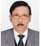 | DR. GOPESH CHANDRA DAS  F/Name: Late Ramdhan Das  M/Name:  BM & DC Reg. No:  NID:  Cell:  Address: Aushad Bithan, Central Road  P.O. Moulovi Bazar  Moulovi Bazar  Blood Group:
6 | Voter No  LM-3900006  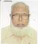 | DR. ABDULLAH AL MAHMUD  F/Name: Al Haj Mohd. Sarafat  M/Name:  BM & DC Reg. No:  NID:  Cell:  Address: South Sylhet Medical Store  Court Road  Moulovi Bazar  Blood Group:  E X P I R E D
7 | Voter No  LM-3900007  No Image | DR. BIBHUTI BHUSAN NATH  F/Name: Late Pran Hari Nath  M/Name:  BM & DC Reg. No:  NID:  Cell:  Address: Aushad Ghar, Srimongol Road  Moulovi Bazar  Blood Group:
8 | Voter No  LM-3900008  No Image | DR. BISWAJIT BHOWMIK  F/Name: Binode Bihari Bhowmik  M/Name:  BM & DC Reg. No:  NID:  Cell:  Address: Doctors Chamber  Sherpur Nutanbazar  Aurangapur  Sylhet  Blood Group:
9 | Voter No  LM-3900009  No Image | DR. RAM CHANDRA MITRA  F/Name: Late Judhistir Mitra  M/Name:  BM & DC Reg. No:  NID:  Cell:  Address: Ratna Clinic, Sherepur Bazar  P.O- Afrujgonj  Moulovi Bazar  Blood Group:
10 | Voter No  LM-3900010  No Image | DR. ARCHANA DEB  F/Name: Late Aswini Deb  M/Name:  BM & DC Reg. No:  NID:  Cell:  Address: Medical Officer  Chest Disease Clinic  Moulovi Bazar  Blood Group:
11 | Voter No  LM-3900011 | DR. MOHAMMED EYAHIA  F/Name: Md. Muttaki  M/Name:  BM & DC Reg. No:  NID:  Cell:  Address: Medical Officer  Sadar UHC  Moulovi Bazar  Blood Group:
12 | Voter No  LM-3900012  No Image | DR. MD. ABDUL AHAD  F/Name: Md. Abdur Rahman  M/Name:  BM & DC Reg. No:  NID:  Cell:  Address: 118, Central Road  Moulovi Bazar  Blood Group:
13 | Voter No  LM-3900013  No Image | DR. DILSHAD PARVEEN  F/Name: Moti Uddin Chowdury  M/Name:  BM & DC Reg. No:  NID:  Cell:  Address: 118, Central Road  Moulovi Bazar  Blood Group:
14 | Voter No  LM-3900014  No Image | DR. MD. SHAHADAT HOSSAIN  F/Name:  M/Name:  BM & DC Reg. No:  NID:  Cell:  Address: TRANSFERED.To. Narsingdi Brancb. LM-23.  Blood Group:  TRANSFERED to BMA Dhaka City  LM-1405543
15 | Voter No  LM-3900015  No Image | DR. SATYA RANJAN DAS  F/Name: Late Kumud Ranjan Das  M/Name:  BM & DC Reg. No:  NID:  Cell:  Address: Sairpur  Moulovi Bazar  Blood Group:
16 | Voter No  LM-3900016 | DR. MD. NAJIBUSH SHAHEED  F/Name: Late Md. Abdus Shadhid  M/Name:  BM & DC Reg. No:  NID:  Cell:  Address: RMO Srimongol Thana  Health Complex  Moulovi Bazar  Blood Group:
17 | Voter No  LM-3900017  No Image | DR. MOHAMMAD MUJIBUR RAHMAN  F/Name: Shafiqur Rahman  M/Name:  BM & DC Reg. No:  NID:  Cell:  Address: Medical Officer  Thana Health Complex  Barolekha  Moulovi Bazar  Blood Group:
18 | Voter No  LM-3900018  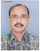 | DR. HEMANTA KUMAR DAS  F/Name: Late Harish Chandra Das  M/Name:  BM & DC Reg. No:  NID:  Cell:  Address: Medical Officer  Sadar Hospital  Moulovi Bazar  Blood Group:
19 | Voter No  LM-3900019  No Image | DR. BIKASH CHANDRA SARKAR  F/Name: Birendra Chandra Sarkar  M/Name:  BM & DC Reg. No:  NID:  Cell:  Address: 47, Shamshernagor Road  Moulovi Bazar  Blood Group:
20 | Voter No  LM-3900020  No Image | DR. ABU BAKAR MD. MOSTAFA  F/Name:  M/Name:  BM & DC Reg. No:  NID:  Cell:  Address: TRANSFERED to BMA Dhaka City  LM- 1859.  Blood Group:  TRANSFERED to BMA Dhaka City  LM-1405543
21 | Voter No  LM-3900021  No Image | DR. ABU SAYEED ABDULLAH  F/Name:  M/Name:  BM & DC Reg. No:  NID:  Cell:  Address: Medical Officer, Thana Health Complex,  Kulaura, Moulovi Bazar  Blood Group:  TRANSFERED to BMA Dhaka City  LM-1405543
22 | Voter No  LM-3900022  No Image | DR. AZIZUL QADAR MD. ABDUL HYE  F/Name:  M/Name:  BM & DC Reg. No:  NID:  Cell:  Address: Medical Officer  Barolekha UHC, Barolekha  Moulvi Bazar  Blood Group:  TRANSFERED to BMA Dhaka City  LM-1405543
23 | Voter No  LM-3900023  No Image | DR. RUKON UDDIN AHMED  F/Name:  M/Name:  BM & DC Reg. No:  NID:  Cell:  Address: TRANSFERED to BMA Sylhet Branch  Blood Group:  TRANSFERED to BMA Dhaka City  LM-1405543
24 | Voter No  LM-3900024  No Image | DR. MD. FAKHRUL ISLAM  F/Name: Late Md. Abdus Samad  M/Name:  BM & DC Reg. No:  NID:  Cell:  Address: T.H & F.P.O  Thana Health Complex  Kulaura  Moulovi Bazar  Blood Group:
25 | Voter No  LM-3900025  No Image | DR. MD. REAZ UDDIN  F/Name: Late Md. Fakhrudin  M/Name:  BM & DC Reg. No:  NID:  Cell:  Address: Kulaura Uttar Bazar  P.O. Kulaura  Moulovi Bazar  Blood Group:
26 | Voter No  LM-3900026 | DR. MD. HADI HOSSAIN  F/Name: Late Md. Mafiz  M/Name:  BM & DC Reg. No:  NID:  Cell:  Address: Lake Road  Moulovi Bazar  Blood Group:
27 | Voter No  LM-3900027 | DR. NAZNEEN AKHTER  F/Name: Shaikh Sirajul Haq  M/Name:  BM & DC Reg. No:  NID:  Cell:  Address: Lake Road  Moulovi Bazar  Blood Group:
28 | Voter No  LM-3900028  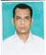 | DR. ABU MUHIT CHOUDHURY  F/Name: Abdul Aziz Choudhury  M/Name:  BM & DC Reg. No:  NID:  Cell:  Address: East Girzapara  Moulvi Bazar  Blood Group:
29 | Voter No  LM-3900029  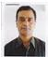 | DR. SUDHAKAR KAIRI  F/Name: Ganesh Ram Kairi  M/Name:  BM & DC Reg. No:  NID:  Cell:  Address: Pulse Diagnostic Centre  Srimangal Road  Moulvi Bazar  Blood Group:
30 | Voter No  LM-3900030  No Image | DR. MONOWAR AHMAD TARAFDAR  F/Name: Late Ali Akbar Tarafdar  M/Name:  BM & DC Reg. No:  NID:  Cell:  Address: Insia Diagnostic Centre  Muslim Quarter  Moulvi Bazar  Blood Group:
31 | Voter No  LM-3900031  No Image | DR. SYED KEFAYET ULLAH  F/Name: Late Syed Abdul Munim  M/Name:  BM & DC Reg. No:  NID:  Cell:  Address: B.N.S.B Base Eye Hospital  Moulvi Bazar  Blood Group:
32 | Voter No  LM-3900032  No Image | DR. ROBERT KHAN  F/Name: Late Mr. Paul Khan  M/Name:  BM & DC Reg. No:  NID:  Cell:  Address: Dakshia Bazar  Kulaura  Moulvi Bazar  Blood Group:
33 | Voter No  LM-3900033 | DR. MUAZZAM HUSSAIN CHOUDHURY  F/Name: Nazibul Hussain Chowdhury  M/Name:  BM & DC Reg. No:  NID:  Cell:  Address: 105, Shah Mostafa Road  Moulvi Bazar  Blood Group:
34 | Voter No  LM-3900034  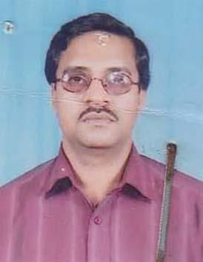 | DR. MD. SHAJAHAN KABIR CHOWDHURY  F/Name: Md. Abdul Mutaleb Chowdhury  M/Name: Late Mrs. Anwara Khanom  BM & DC Reg. No: 22209  NID: 5827407127448  Cell: 01715207208  Address: The Pulse Computerized Diagnostic Center Sreemongal Road, Moulovi Bazar  Blood Group: A+
35 | Voter No  LM-3900035 | DR. AVIJIT ROY  F/Name: Shanti Ranjan Roy  M/Name: Geeta Debi  BM & DC Reg. No: 23649  NID: 5827401105515  Cell: 01711314820  Address: Insia Diagnostic Center, 11, K.B. Alauddin Road, Muslim Quarter, Moulvibazar  Blood Group: B+
36 | Voter No  LM-3900036  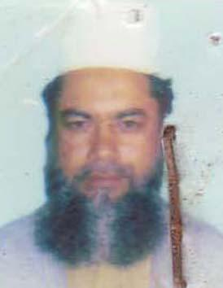 | DR. MD. ABUL KALAM  F/Name: Md. Abdul Jalil  M/Name: Mrs. Marium Begum  BM & DC Reg. No: 14219  NID: 9121704658284  Cell:  Address: Upo-zila Health Complex, Barlekha, Moulvibazar  Blood Group: O+
37 | Voter No  LM-3900037 | DR. ILARIUS-E-REMA  F/Name: Late Bimol Dalbot  M/Name: Mrs. Rezina Rema  BM & DC Reg. No: 28215  NID: 5826504454549  Cell: 01719089839  Address: Sate Maternity & Surgical Clinic Daxia Bazar, Kulaura, Moulvibazar  Blood Group: A+
38 | Voter No  LM-3900038  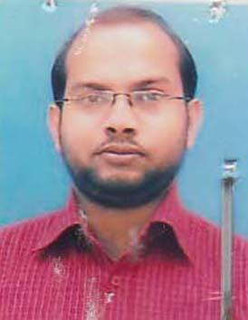 | DR. SHAH AMINUL ISLAM  F/Name: Late Dr. Shah Nurul Islam  M/Name: Late Anwara Begum  BM & DC Reg. No: 34162  NID: 5827401105404  Cell: 01715001925  Address: Panthonibash, 24 Sayerpur School RD, P.O & Dist: Moulvibazar-3200  Blood Group: AB_po
39 | Voter No  LM-3900039 | DR. MD. DELWAR HOSSAIN  F/Name: Late Md. Chand Backsha Khan  M/Name: Late Sademennessa  BM & DC Reg. No: 17202  NID: 5827404114660  Cell: 01711406451  Address: Consultant (Paed) Sadar Hospital, Moulvibazar  Blood Group: B-
40 | Voter No  LM-3900040  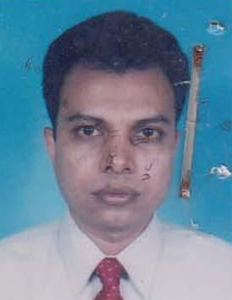 | DR. SUBRATA KUMAR ROY  F/Name: Late Aswini Kumar Roy  M/Name: Late Protiva Rani Roy  BM & DC Reg. No: 18948  NID: 5827407128555  Cell: 01711345031  Address: 73/1, Nahid Monjil Sadar Hospital Road, Moulvibazar  Blood Group: AB_po
41 | Voter No  LM-3900041  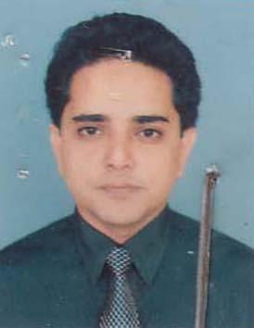 | DR. MD. ZAHED PARVEZ  F/Name: M. H. Rashid  M/Name: Begum Jebunnesa  BM & DC Reg. No: 25557  NID: 5827402108028  Cell: 01715050949  Address: 32/1 Circuit House Road, Moulvibazar  Blood Group: A+
42 | Voter No  LM-3900042  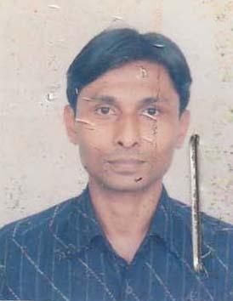 | DR. ASAD DIN MAHMOOD  F/Name: Abdullah Al Mahmood  M/Name: Begum Nurunnahar  BM & DC Reg. No: 36320  NID: 5827401100100  Cell: 01914499540  Address: 2/1 Sahbagh, (Old. 20), Kashinath Road, Moulvibazar-3200  Blood Group: O+
43 | Voter No  LM-3900043 | DR. MANOJ BIKASH CHAKMA  F/Name: Late. Sabaha Bikash Chakma  M/Name: Mrs. Nilima Chakma  BM & DC Reg. No: 42783  NID: 5827408135361  Cell: 01718350563  Address: Sabujbag, Shreemongol Road, Moulvibazar  Blood Group: A+
44 | Voter No  LM-3900044  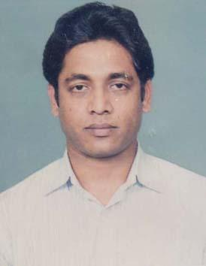 | DR. GOPAL CHANDRO MONDAL  F/Name: Arabindo Kumar Mondal  M/Name: Minati Rani Mondal  BM & DC Reg. No: 45141  NID: 2693016106157  Cell: 01754595439  Address: Latif Khan Villa (1st Floor), Muslim Quater, Moulvibazar  Blood Group: B+
45 | Voter No  LM-3900045  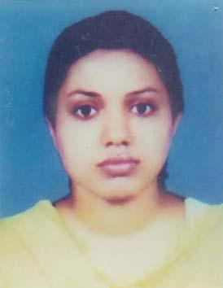 | DR. SHAHINA AKTER  F/Name: Shahab Uddin Khan  M/Name: Rehana Begum  BM & DC Reg. No: 46713  NID: 2693016106156  Cell: 01733521232  Address: Latif Khan Villa (1st Floor), Muslim Quater, Moulvibazar  Blood Group: B+
46 | Voter No  LM-3900046  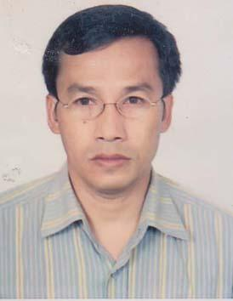 | DR. R.K.S ROYEL  F/Name: Bir Chandra Singha  M/Name: Reboti Devi  BM & DC Reg. No: 27950  NID:  Cell: 01712637681  Address: 1/B Professor\'s Quarter, New Campass Sylhet MAG Osmani Medical College, Sylhet  Blood Group: B+
47 | Voter No  LM-3900047 | DR. BORNALI DAS  F/Name: Dr. Gopesh Chandra Das  M/Name: Namita Das  BM & DC Reg. No: 38779  NID: 5827401101623  Cell: 01717795254  Address: 113, Purba Girga Para, Moulvibazar-3200  Blood Group: O-
48 | Voter No  LM-3900048  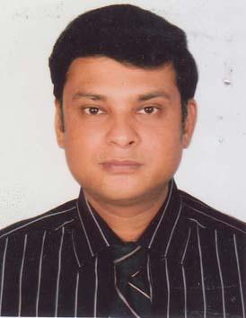 | DR. MD. ABDUL HADI  F/Name: Late Abdul Mosabbir  M/Name: Badrunnessa Khanom  BM & DC Reg. No: 28021  NID: 5817480280791  Cell: 01711899870  Address: Badrunnessa Pvt. Hospital Islambagh, Sreemongle Road, Moulvibazar-3200  Blood Group: B+
49 | Voter No  LM-3900049  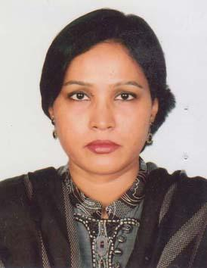 | DR. ZAKIA SHAHID KHAN  F/Name: Mohammad Shahidullah Khan  M/Name: Rasheda Akhter Khan  BM & DC Reg. No: 29827  NID: 5817480280793  Cell: 01711709535  Address: Baorunnessa Pvt. Hospital, Islambagh, Sreemongal Road, Moulvibazar-3200  Blood Group: B+
50 | Voter No  LM-3900050  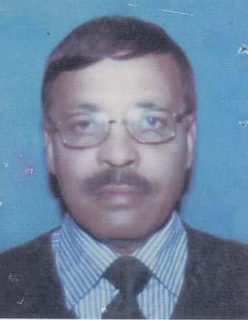 | DR. MD. MONIRUL ISLAM  F/Name: Late. Md. Abdus Sabur  M/Name: Late Jabun Nessa Khanam  BM & DC Reg. No: 8822  NID: 5816571614633  Cell: 01711904961  Address: Rabir Bazar PO: Prithimpassa, Kulaura, Moulvibazar  Blood Group: A+
51 | Voter No  LM-3900051  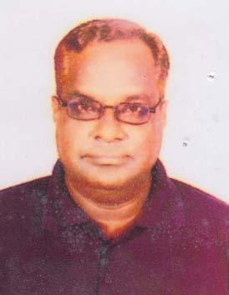 | DR. AMITABHA DE  F/Name: Late Dr. Upendra Chandra De  M/Name: Mrs. Dipti Rani De  BM & DC Reg. No: 13757  NID: 5826504453554  Cell: 01711300260  Address: UH & FPO, Kulawra, Moulvibazar  Blood Group: O+
52 | Voter No  LM-3900052  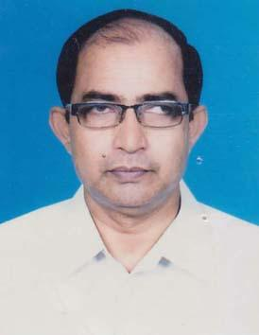 | DR. MD. SARWAR HOSSAIN  F/Name: Late Asir Uddin Ahmed  M/Name: Late Rahima Begum  BM & DC Reg. No: 15531  NID:  Cell: 01711376793  Address: UH&FPO, P.O+P.S- Jiri, Dist- Moulvibazar  Blood Group:
53 | Voter No  LM-3900053  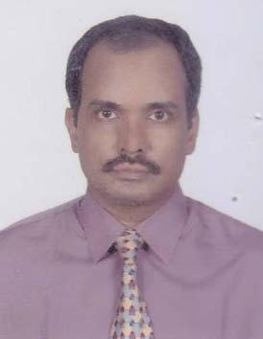 | DR. ARUNABHA DE  F/Name: Late Dr. Upendra Chandra De  M/Name: Dipti Rani De  BM & DC Reg. No: 19887  NID: 5826508452149  Cell: 01715582305  Address: Jui Plaza, Uslapara, Kulaura, Moulvibazar  Blood Group: A+
54 | Voter No  LM-3900054  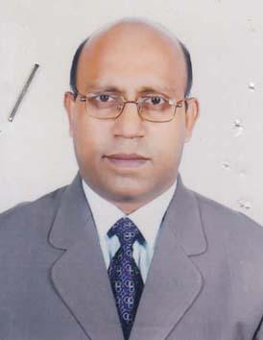 | DR. PRODIP KUMAR ROY  F/Name: Kamal Lal Roy  M/Name: Dulali Roy  BM & DC Reg. No: 20944  NID: 5826504453558  Cell: 01711738916  Address: Bakhtunnessa Chowdhury Diabetes Centre, Kulaura, Moulvibazar  Blood Group: O+
55 | Voter No  LM-3900055  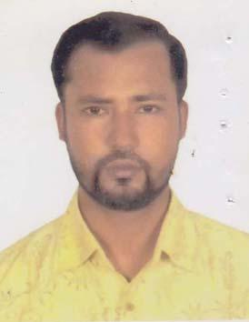 | DR. MOHI UDDIN AHMED  F/Name: Shiraj Uddin Ahmed  M/Name: Hosne-Ara Begum  BM & DC Reg. No: 27836  NID: 2690815064498  Cell: 01720181171  Address: Medical Officer Upazilla Health Complex Kulaur, Moulvibazar  Blood Group: O+
56 | Voter No  LM-3900056  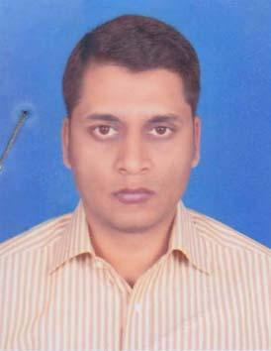 | DR. ASAD IMAM  F/Name: Mr. Nisar Ahmed  M/Name: Mrs. Mehjabeen Ahmed  BM & DC Reg. No: 38072  NID: 19737328507000002  Cell: 01712144441  Address: F-4, Bulding-2, 44 "Malancha" Shamsher Nagar Road, Moulvibazar  Blood Group: A+
57 | Voter No  LM-3900057  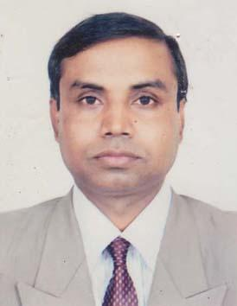 | DR. MD. SULTAN AHMED  F/Name: Md. Abdul Mojid  M/Name: Begum Koklibun Nessa  BM & DC Reg. No: 21310  NID: 5827408135359  Cell: 01711316843  Address: Medical Officer (MCH-FP), Upazilla Health Complex, Kulaura, Moulvibazar  Blood Group: O+
58 | Voter No  LM-3900058  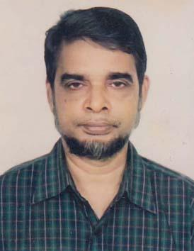 | DR. MD. NAZRUL ISLAM  F/Name: Late Md. Siraj Uddin  M/Name: Late Mrs. Mizazun Nahar  BM & DC Reg. No: 14481  NID: 5827407128899  Cell: 01670614780  Address: Sadar Hospital, Maulovibazar  Blood Group: B+
59 | Voter No  LM-3900059  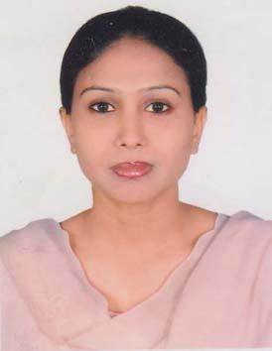 | DR. JANNATH ARA FERDOUS  F/Name: Monowar Hussain  M/Name: Yesmin Hussain  BM & DC Reg. No: 48825  NID: 2692848062295  Cell: 01716279002  Address: 211 Shahbag, Kashinth Road, Moulovibazar  Blood Group:
60 | Voter No  LM-3900060 | DR. MD. SOHEL RANA  F/Name: Md. Solaiman Miah  M/Name:  BM & DC Reg. No: A35940  NID:  Cell:  Address: City Diagnostic Centre, Sreemongol Road, Moulvibazar  Blood Group:
61 | Voter No  LM-3900061  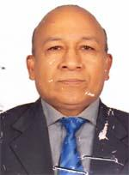 | DR. GOUR MONI SINHA  F/Name: Late Babu Sinha  M/Name: Juboti Sinha  BM & DC Reg. No: 24457  NID: 5825602884088  Cell: 01728206470  Address: Vill-Panishala, post-kamalganj, Upazilla-Kamalganj, Dist-Moulvibazar  Blood Group: O+
62 | Voter No  LM-3900062 | DR. SHAFIQUE UDDIN AHMED  F/Name: Late Rais Uddin Ahmed  M/Name: Late Joytunnessa  BM & DC Reg. No: 4304  NID: 5827401100445  Cell: 01711468646  Address: 162, West Sayer Pur, Kashinal Moulvibazar, post+dist-Moulvibazar  Blood Group: B+
63 | Voter No  LM-3900063  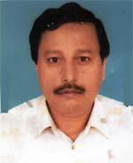 | DR. DINESH SUTRADHAR  F/Name: Late Matilal Sutradhar  M/Name: Late Hirun Bala Sutradhar  BM & DC Reg. No: 9126  NID: 8527404115253  Cell: 01711476582  Address: 81, Muslim Quarter, Moulvi Bazar-3200  Blood Group: O+
64 | Voter No  LM-3900064  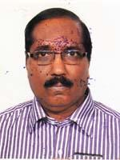 | DR. KANTI BHUSAN BHATTACHARGEE  F/Name: Late Krishna Pada Bhattacharjee  M/Name: Late Bishnupiya Bhattacharjee  BM & DC Reg. No: 14088  NID: 581657515354  Cell: 01711973167  Address: Temporary Nazma Villa, Chubra, Moulvibazar  Blood Group: B+
65 | Voter No  LM-3900065  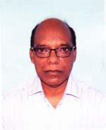 | DR. PADMA MOHAN SINHA  F/Name: Rajendra Kumar Sinha  M/Name: Chawbi Debi  BM & DC Reg. No: 14930  NID: 5827401105181  Cell: 01712140865  Address: Vice Principal, MATS, Moulvibazar  Blood Group: O+
66 | Voter No  LM-3900066 | DR. ALOKE RANJAN DAS  F/Name: Late Ketaki Ranjan Das  M/Name: Dipali Das  BM & DC Reg. No: 15166  NID: 5827401105664  Cell: 01735360640  Address: 250 Bed Hospital, Maulvibazar  Blood Group: O+
67 | Voter No  LM-3900067 | DR. MD. ABDUL MANNAN  F/Name: Late Afaz Uddin  M/Name: Rahima Khatun  BM & DC Reg. No: 18695  NID: 5827404113938  Cell: 01711183945  Address: MCWC (Matrimaugul), Old, Hospital Road, Moulvibazar  Blood Group: AB+
68 | Voter No  LM-3900068  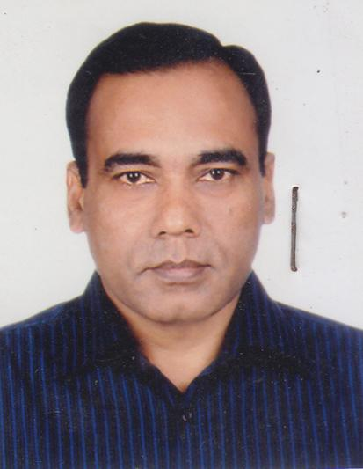 | DR. MD. SHAFIQUR RAHMAN  F/Name: Md. Abdul Matin  M/Name: Mrt. Moriam Begum  BM & DC Reg. No: 17170  NID: 5827408133407  Cell: 01722294159  Address: K. K. Medicine Center, Sree Road, Moulvibazar  Blood Group: O+
69 | Voter No  LM-3900069 | DR. ABDULLAH AL BAKI  F/Name: Md. Masland  M/Name: Surjahan Begum  BM & DC Reg. No: 25283  NID: 2696352224566  Cell: 01774871737  Address: Flat No. 9(C), Shah Mostafa Garden City, M. Saifun Rahaman Rd, Moulvibazar  Blood Group: B+
70 | Voter No  LM-3900070 | DR. MOHAMMAD ABBAS UDDIN AHMED  F/Name: Mohammad Monir Uddin Ahmed  M/Name: Farida Begum Chowdhury  BM & DC Reg. No: 40846  NID: 6725804367801  Cell: 01673889762  Address: Sadar Hospital, Moulovibazar.  Blood Group: O+
71 | Voter No  LM-3900071 | DR. BINENDU BHOWMICK  F/Name: Birendra Bihari Bhowmick  M/Name: Sukriti Bhowmick  BM & DC Reg. No: 32078  NID: 5828301040467  Cell: 01676862906  Address: UH & FPO, Sadar, Moulvibazar  Blood Group: A+
72 | Voter No  LM-3900072 | DR. PEARLY DAS  F/Name: Dr. Gopesh Chandra Das  M/Name: Namita Das  BM & DC Reg. No: 54570  NID: 5827401105358  Cell: 01728551403  Address: 113, Purbo Girzapara, Moulvibazar-3200  Blood Group: O+
73 | Voter No  LM-3900073 | DR. MD. ABDULLAH AL MARUF  F/Name: Md. Abdur Rahim  M/Name: Aleya Begum  BM & DC Reg. No: 46351  NID: 2697556419294  Cell: 01712009720  Address: 250 Bed Hospital, Moulvibazar  Blood Group: A+
74 | Voter No  LM-3900074  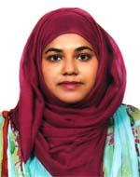 | DR. MIRZA FARZANA HOLU  F/Name: Mirza Farid Ahmed Beg  M/Name: Momtaz Begum  BM & DC Reg. No: 46349  NID: 581742228706  Cell: 01717459337  Address: 250 Bed Hospital, Moulvibazar  Blood Group: A+
75 | Voter No  LM-3900075 | DR. MD. UBAIDUL ISLAM  F/Name: Md. Nurul Islam  M/Name: Diluara Begum  BM & DC Reg. No: 47160  NID: 5827401100951  Cell: 01726889996  Address: 52 Girjapara , Moulvibazar-3200  Blood Group: B+
76 | Voter No  LM-3900076  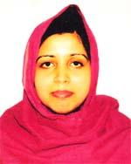 | DR. NARGIS AKHTER CHOWDHURY  F/Name: Md. Altaf Uddin Chowdhury  M/Name: Fathema Akhter Chowdhury  BM & DC Reg. No: 46760  NID: 9111711991651  Cell: 01619048084  Address: 52, Girja Para, Moulvibazar, 3200  Blood Group: O+
77 | Voter No  LM-3900077 | DR. MD. ABU RAYHAN  F/Name: Md. Hatem Ali  M/Name: Mrs. Afruza Khatun  BM & DC Reg. No: 36860  NID: 2694066784880  Cell: 01711888955  Address: 172/6, East Dharkapon Road, Moulvibazar  Blood Group: AB+
78 | Voter No  LM-3900078  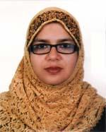 | DR. ESMAT JAHAN  F/Name: Dr. Md. Ibrahim Hossain  M/Name: Mrs. Rownak Ara Begum  BM & DC Reg. No: 43335  NID: 2694066784882  Cell: 01710812271  Address: 172/6, East Dharkapon Road, Moulvibazar  Blood Group: B+
79 | Voter No  LM-3900079 | DR. MD. ABU IMRAN  F/Name: Md. Hatem Ali  M/Name: Mrs. Afruza Khatun  BM & DC Reg. No: 42594  NID: 2694066782591  Cell: 01710920629  Address: 172/6, East Dharkapon Road, Moulvibazar  Blood Group: AB+
80 | Voter No  LM-3900080  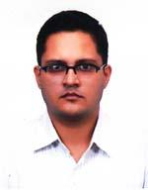 | DR. SYED ABUL FOEZ  F/Name: Syed Mohammad Akbar  M/Name: Syeda Ahmuda  BM & DC Reg. No: 36186  NID: 2695047983641  Cell: 01711836820  Address: Srimongol Road, Moulvibazar  Blood Group: O+
81 | Voter No  LM-3900081 | DR. BISHWAJIT DEB  F/Name: Gouri Shankar Deb  M/Name: Pritikona Deb  BM & DC Reg. No: 40555  NID: 9196208409742  Cell: 01712540604  Address: Saiyer Pur School Road, Moulvibazar, Post+Dist-Moulvibazar  Blood Group: AB+
82 | Voter No  LM-3900082  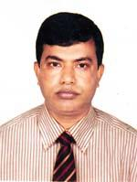 | DR. MD. BABUL AKHTER  F/Name: Md. Tofazzal Hossain Molla  M/Name: Halima Khatun  BM & DC Reg. No: 26010  NID: 8524904047373  Cell: 01712970889  Address: Jr. Consultant Surgery, 250 Bed Hospital, Moulvibazar  Blood Group: AB+
83 | Voter No  LM-3900083 | DR. POLASH ROY  F/Name: Pankaj Kumar Roy  M/Name: Nanda Rani Das  BM & DC Reg. No: 42193  NID: 6725805709183  Cell: 01711154363  Address: 387/A, Nazma Villa, Chubra Road, Moulvibazar.  Blood Group: O+
84 | Voter No  LM-3900084  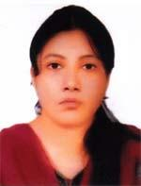 | DR. MOAUMITA DAS  F/Name: Shyama Pada Das  M/Name: Smiti Rekha Das  BM & DC Reg. No: 63006  NID: 9326602050753  Cell: 01724039452  Address: 387/A Nazma Villa, Chubra Road, Moulvibazar  Blood Group: O+
85 | Voter No  LM-3900085 | DR. A. Z. M. MOTIUR RAHMAN  F/Name: Late Mofiz Uddin Ahmed  M/Name: Late Firoza Khatun  BM & DC Reg. No: 17279  NID: 5827402108026  Cell: 01711868929  Address: 236, N. R. Monjil, Dorga Moholla, Moulvibazar-3200  Blood Group: B+
86 | Voter No  LM-3900086  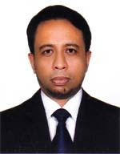 | DR. ABUL KALAM MOHAMMAD SHOAB  F/Name: Mohammed Abdul Hannan  M/Name: Payara Begum  BM & DC Reg. No: 30957  NID: 5818031434847  Cell: 01718067810  Address: Vill-Katazuri, Post-Rajnagar, Thana-Rajnagar, Dist-Moulvibazar  Blood Group: O+
87 | Voter No  LM-3900087  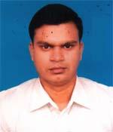 | DR. MOHAMMAD SHIRAJUR RAHMAN  F/Name: Late Md. Sajidur Rahman  M/Name: Mrs. Jamila Khatun  BM & DC Reg. No: 32429  NID: 9196211229122  Cell: 01712081850  Address: 139, Nobab Road, Kajolshah, Sylhet  Blood Group: O+
88 | Voter No  LM-3900088 | DR. MD. SHAHIN AHMED  F/Name: Md. Abdul Ali  M/Name: Anawara Begum  BM & DC Reg. No: 69341  NID: 198619267090584  Cell: 01716278876  Address: 24, Sakib Complex, Geerza Para, Moulvibazar-3200  Blood Group: O+
89 | Voter No  LM-3900089  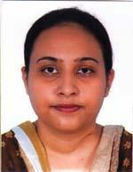 | DR. SADIA KHAN  F/Name: Dr. Ghulam Anwer Khan  M/Name: Rafia Begum  BM & DC Reg. No: 69765  NID: 1926711080111  Cell: 01742051784  Address: Tila Bari, TB Hospital Road, Moulvibazar-3200  Blood Group: A+
90 | Voter No  LM-3900090 | DR. MD. IQBAL HASAN  F/Name: Md. Aklis Miah  M/Name: Rowshan Ara Begum  BM & DC Reg. No: 60975  NID: 5827401105617  Cell: 01737373182  Address: 84, Riyasath Ullah Road, Syerpur, Moulvibazar-3200  Blood Group: O+
91 | Voter No  LM-3900091 | DR. SWAPAN KUMAR SINGHA  F/Name: Lal Mohan Singha  M/Name: Rosobati Sinha  BM & DC Reg. No: 31085  NID: 5815617004092  Cell: 01816457337  Address: 250 Bed Hospital, Moulvibazar  Blood Group: O+
92 | Voter No  LM-3900092  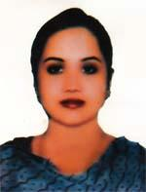 | DR. SUNIA SINHA  F/Name: Dr. Gourmani Sinha  M/Name: Swapana  BM & DC Reg. No: 59226  NID:  Cell: 01718697474  Address: UHC, Sadar, Moulvibazar  Blood Group: O+
93 | Voter No  LM-3900093  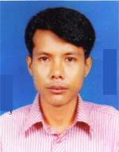 | DR. SAMARJIT SINGAH  F/Name: Binoy Kumar Singha  M/Name: Sabitri Devi  BM & DC Reg. No: 42954  NID: 19785813567665947  Cell: 01710891343  Address: Upazilla Health Complex, Juri, Moulvi Bazar  Blood Group: O+
94 | Voter No  LM-3900094  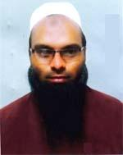 | DR. ABDUL MAJID  F/Name: Abdul Ahad  M/Name: Hosne Ara Begum  BM & DC Reg. No: 50251  NID: 5815617004574  Cell: 01711988373  Address: 250 Bed Hospital, Moulvibazar  Blood Group: A+
95 | Voter No  LM-3900095 | DR. ABDULLAH AL MAMUN  F/Name: Wahid Uddin Ahmed  M/Name: Fatema Begum  BM & DC Reg. No: 38419  NID: 2690243858783  Cell: 01760312333  Address: Sadar 250 Bed Hospital, Moulvibazar  Blood Group: AB+
96 | Voter No  LM-3900096  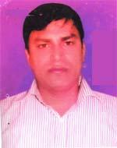 | DR. VRIGUMOL SINGHA BIMOL  F/Name: Kamini Mohon Singha  M/Name: Faza Devi  BM & DC Reg. No: 49079  NID: 5815617001916  Cell: 01727414243  Address: Medical officer, 250 Beded Hospital, Moulvibazar  Blood Group: A+
97 | Voter No  LM-3900097 | DR. SANGHAMITRA DEY  F/Name: Late Sudhangshu Ranjan Dey  M/Name: Malaya Dey  BM & DC Reg. No: 64508  NID: 19895827404117395  Cell: 01717130466  Address: 7/1, Corner View, Subidbazar,Moulvibazar Sylhet  Blood Group: B+
98 | Voter No  LM-3900098 | DR. TAMAL KANTI KAIRI  F/Name: Sudhakar Kairi  M/Name: Raboti Kairi  BM & DC Reg. No: 64505  NID: 5827407130343  Cell: 01719333609  Address: 7/1, Corner View, Subidbazar, Sylhet, Moulvibazar  Blood Group: O+
99 | Voter No  LM-3900099 | DR. SYED AKHTAR HOSSAIN  F/Name: Late Syed Amirul Hussain  M/Name: Late Syeda Saira Begum  BM & DC Reg. No: 8486  NID: 5827403112945  Cell: 01711138172  Address: 255/1 Bonobithy R/A, Wapda Road, Moulvibazar  Blood Group: O+  E X P I R E D
100 | Voter No  LM-3900100  No Image | ***NIL***  F/Name:  M/Name:  BM & DC Reg. No:  NID:  Cell:  Address:  Blood Group:
101 | Voter No  LM-3900101  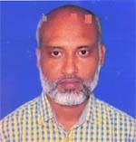 | DR. MD. SHAMIMUR RAHMAN  F/Name: Late Md. Azizur Rahman  M/Name: Begum Nurunnahar  BM & DC Reg. No: 34646  NID: 19755827401000001  Cell: 01711021810  Address: 168, Shahbali, Post+Dist-Moulvibazar, Post Code-3200  Blood Group: A+
102 | Voter No  LM-3900102  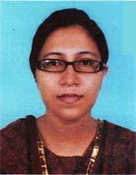 | DR. FADILA AHMED TINNY  F/Name: Kaiser Ahmed  M/Name: Pervin Ahmed  BM & DC Reg. No: 46383  NID: 5827404114618  Cell: 01711703297  Address: 47, Gani Manzil, Muslim Quaters, Moulvibazar  Blood Group: O+
103 | Voter No  LM-3900103 | DR. AMZAD HOSSAIN  F/Name: Md. Askir Miah  M/Name: Mrs. Lutfunnesa  BM & DC Reg. No: 52750  NID: 19855817421224831  Cell: 01712219644  Address: Medical officer, Upazilla Health Complex, Rajnagar, Moulvibazar  Blood Group: AB+
104 | Voter No  LM-3900104  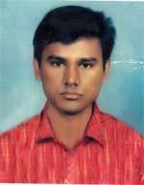 | DR. RAFI AHMED KHAN  F/Name: Sayef Uddin Ahmed Khan  M/Name: Rosena Akther Khanam  BM & DC Reg. No: 45486  NID: 9196208188968  Cell: 01717795210  Address: Vill 2 P. O. Shamsher Nagar, P.s Kamalgonj, Dist-Moulvibazar  Blood Group: B+
105 | Voter No  LM-3900105  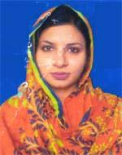 | DR. ROWSHAN ARA JAMAN  F/Name: Md. Badruzzaman  M/Name: Mrs. Lovely Begum  BM & DC Reg. No: 45530  NID: 9196203123282  Cell: 01732723497  Address: N. R. Manjil, Dorga Mohalla, Moulvibazar  Blood Group: O+
106 | Voter No  LM-3900106 | DR. NANTI BIKASH TRIPURA  F/Name: Nirendra Lal Tripura  M/Name: Mrs. Gopadebi Tripura  BM & DC Reg. No: 42034  NID:  Cell: 01710993716  Address: BCHP, P. o Kajal dhara , Moulvibazar  Blood Group: B+
107 | Voter No  LM-3900107  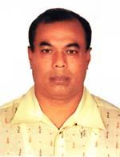 | DR. KAMAL RATAN SAHA  F/Name: Late Kasheb Ch. Saha  M/Name: Bashanti Rani Saha  BM & DC Reg. No: 14855  NID: 5826504453461  Cell: 01745527442  Address: 174, Purnimaloy, Uttar Megwa, Kulceher, Moulvibazar  Blood Group: AB+
108 | Voter No  LM-3900108 | DR. FARZANA HOQUE PARNA  F/Name: Enamul Hoque  M/Name: Shamim Sultana  BM & DC Reg. No: 37371  NID: 2619551165514  Cell: 01712532380  Address: Flat 4D, Rosedeu House, Pagulla Road, Islambagh, Moulvibazar-3200  Blood Group: AB+
109 | Voter No  LM-3900109 | DR. ISHTIAQ ALAM  F/Name: Md. Shafiul Alam  M/Name: Dr. Hamida Haider  BM & DC Reg. No: 37370  NID: 19792619551165513  Cell: 01711173240  Address: Flat-4D, Rose dell House, Pagulla Road, Islam Bagh, Moulvibazar-3200  Blood Group: A-
110 | Voter No  LM-3900110 | DR. BICITHRA KUMAR DEY  F/Name: Late Barada Kumar Dey  M/Name: Niva Rani Dey  BM & DC Reg. No: 42412  NID: 5827401105380  Cell: 01716938572  Address: Ahad Tower, House No. 16/1, Block-C, Pomitula, Thana-Jalalabad, Sylhet  Blood Group: O+
111 | Voter No  LM-3900111 | DR. CHANDRA DEB RAKHI  F/Name: Subash Chandra Deb  M/Name: Ratna Rani Deb  BM & DC Reg. No: 70412  NID: 19889196208000005  Cell: 01773036449  Address: Ahad Tower, House No. 16/1, Block-1, Srimangal, Dist-Moulvibazar  Blood Group: O+
112 | Voter No  LM-3900112 | DR. RUKSHANA WAHID RAHI  F/Name: Abdul Wahid  M/Name: Hose Ne Ara Wahid  BM & DC Reg. No: 57688  NID: 5827401103632  Cell: 01737232124  Address: House No. 2, Road No. 5, Binahinpur, College Road, Sreemangal, Moulvibazar  Blood Group: O+
113 | Voter No  LM-3900113 | DR. AHMED HOSSAIN  F/Name: Abdul Mannan  M/Name: Rehijan Begum  BM & DC Reg. No: 32510  NID: 19765815617005633  Cell: 01712113831  Address: Upazilla Health Complex, Barlekha, Moulvibazar  Blood Group: O+
114 | Voter No  LM-3900114 | DR. AYESHA TASNIM ISHITA  F/Name: Dr. M. A. Ahad  M/Name: Dr. Dilshad Parveen  BM & DC Reg. No: 48184  NID: 2691649108976  Cell: 01717483663  Address: 118, Central Road, Moulvibazar-3200, Moulvibazar  Blood Group: AB+

